# Atlanta Population

1. use db.zipcodes.find() to filter results to only the results where city is ATLANTA and state is GA.

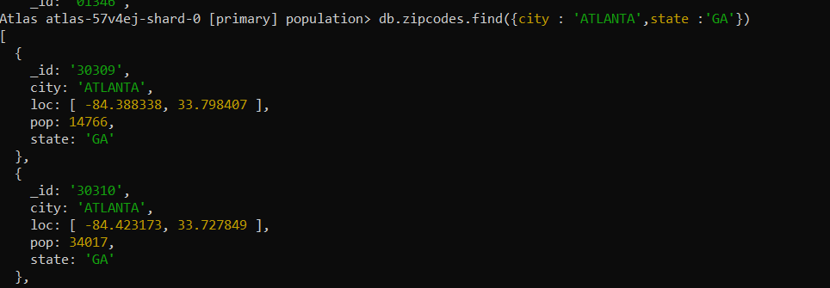

1. use db.zipcodes.aggregate with $match to do the same as above.

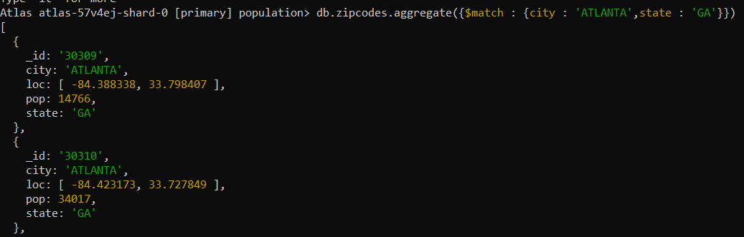

1. use $group to count the number of zip codes in Atlanta.



# Populations By State

1. use aggregate to calculate the total population for each state

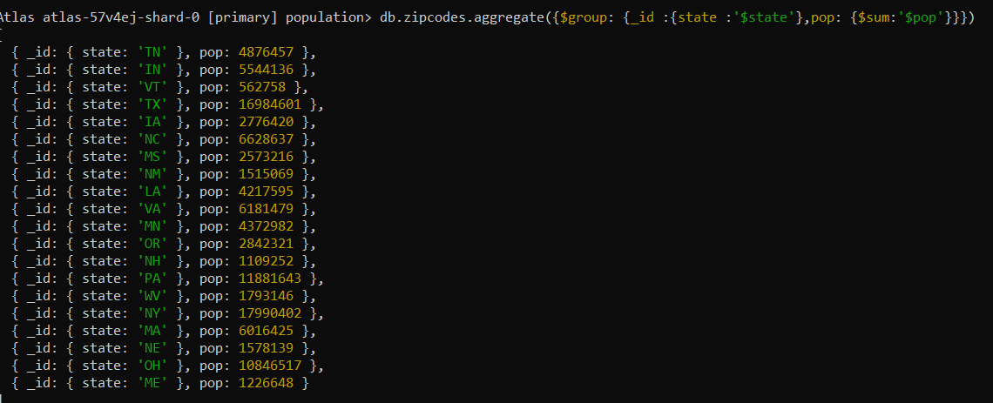

1. sort the results by population, highest first

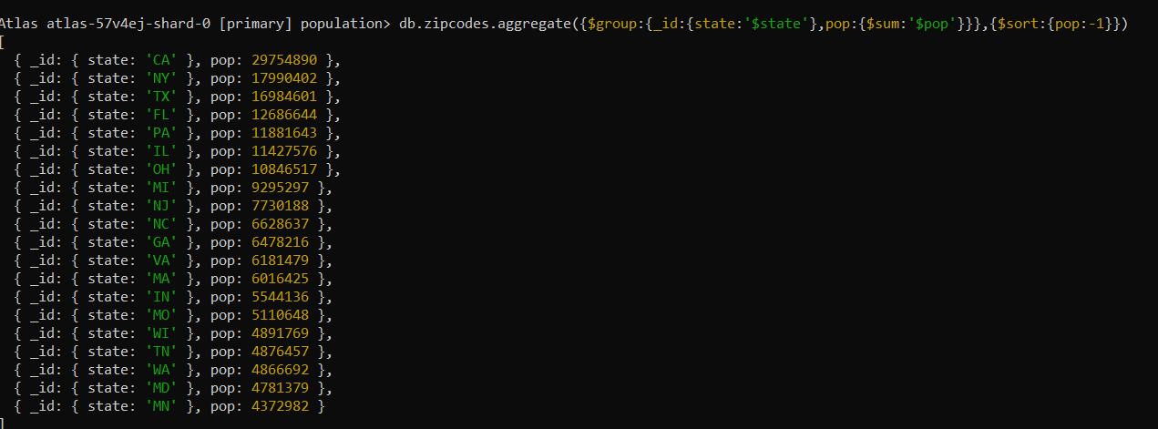

3. limit the results to just the first 3 results. What are the top 3 states in

population?



# Populations by City

1.

use aggregate to calculate the total population for each city (you have to use

city/state combination). You can use a combination for the _id of the $group: {

city: '$city', state: '$state' }

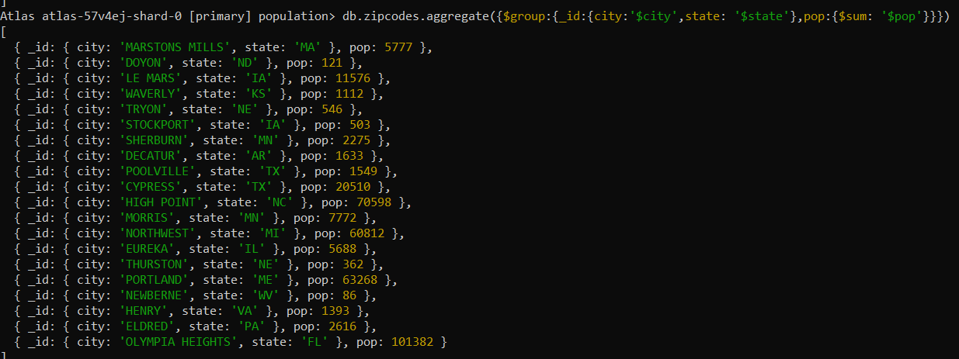

1. sort the results by population, highest first

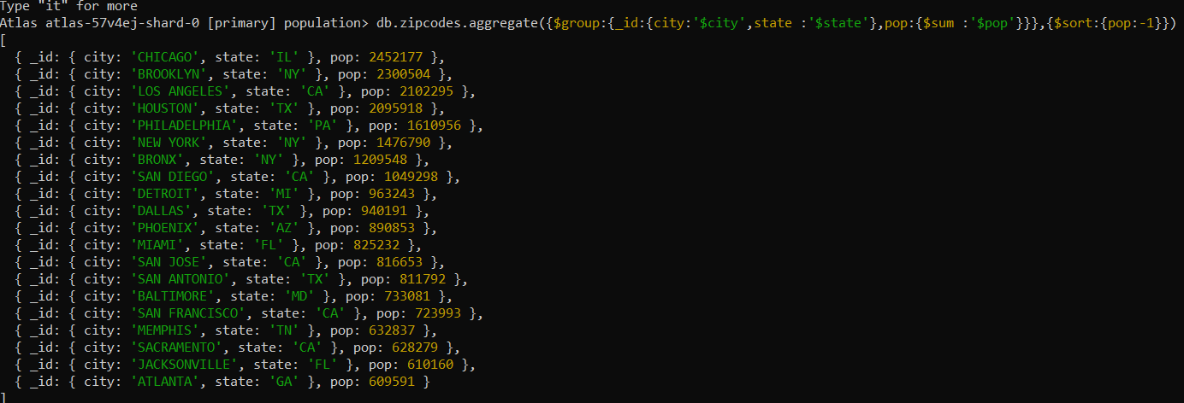

3. limit the results to just the first 3 results. What are the top 3 cities in

population?



1. What are the top 3 cities in population in Texas?

# Bonus

1. Write a query to get the average city population for each state.

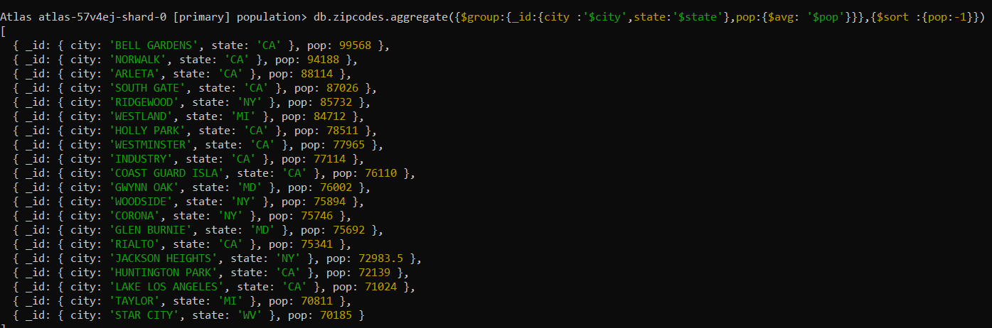

1. What are the top 3 states in terms of average city population?

